Enterprise Deployment and Monitoring Architecture
National Retail Corp GenAI Platform: AskRetail, StockSense, HRHelper
Prepared by Dennis · LC 3 Project Module · October 2026

Executive Summary
My top design choice is one shared GenAIOps pipeline and Azure API Management AI gateway that apply risk-tiered controls per app, instead of three separate platforms. Sharing build, versioning and gateway policies removes duplicated infrastructure and enforces per-app token quotas for CFO showback, while switching traffic at the gateway contains operational risk by keeping rollback within 3–5 minutes. Automated numeric gates let routine releases ship twice weekly, with human approvals and longer observation added only where risk demands it, chiefly for HRHelper.

1. Scenario and Risk Classification
Design choices trace to the NRC scenario brief, which governs wherever the supporting templates differ.
App | Risk class | Driving constraints | Orchestrator | Rollout
AskRetail | Tier 1, customer-facing | 15× BFCM burst; p99 ≤ 2.5 s; 99.95%; ≤ $0.04/conversation | AKS | Blue/green
StockSense | Tier 2, internal data | Morning batch done by 09:00; MAPE < 8%; SOX lineage | Azure Container Apps (serverless) | Canary
HRHelper | Tier 1-S, internal sensitive | SSN, medical, harassment data; private network; immutable audit | Private AKS | Blue/green, extended

2. CI/CD Pipeline Architecture

2.1 Stages and versioned assets (C1–C3, C5)
One multi-stage YAML pipeline (Azure DevOps or GitHub Actions, OIDC to Azure, no stored secrets) serves all apps: build, model validation and packaging are shared; evaluation, promotion and rollout run in per-app lanes (Figure 1). All assets are immutable and versioned:
- Code, prompts and IaC live in Git (prompts as JSON/YAML bundles, plus Bicep and APIM policies); main needs 2+ reviewers (Tier 1) or 1+ (Tier 2) and signed commits.
- Images carry commit SHA and semantic version tags and deploy by digest.
- Models are pinned in the Azure AI Foundry Model Catalog (e.g., gpt-4o-2026-01-15); Model Validation rejects “latest” references and checks prompt-to-model compatibility.
- Release bundles (release-{app}-{version}.zip) hold image digest, prompt manifest, model reference, Bicep and evaluation report; the registry tracks the last-known-good bundle.

2.2 Automated evaluation gates (C4)
Any blocking failure rejects the release and notifies the PR author. Latency uses the brief’s p95 SLAs where the template differs.
Gate | AskRetail | StockSense | HRHelper
Quality | Groundedness ≥ 0.92; hallucination < 1.5% | MAPE < 8% (30-day holdout) | Groundedness ≥ 0.90; hallucination < 2.0%; escalation accuracy ≥ 95%
Latency | p50 ≤ 800 ms, p99 ≤ 2.5 s (500 users) | Ad-hoc p95 ≤ 8 s; 10,000-SKU batch ≤ 45 min | p95 ≤ 3.5 s, p99 ≤ 6 s
Tests | Unit ≥ 85%; integration 100%; errors < 0.1% | Unit ≥ 70%; SAP/Synapse integration ≥ 95%; errors < 1% | Unit ≥ 80%; integration 100%; errors < 0.5%
Security, safety | 0 Critical/High vulnerabilities; 0 hate/violence | 0 Critical/High vulnerabilities | 0 Critical/High; 0 safety violations; PII and WORM audit checks
Cost (warn) | ≤ $0.04/request | ≤ $0.12/request | ≤ $0.08/request

2.3 Environment promotion and approvals (C6)
Dev deploys automatically on green builds; staging adds integration and load tests; production approvals are recorded in Azure DevOps Environments under MFA.
Environment | AskRetail | StockSense | HRHelper
Staging | CDO delegate + Platform Eng | CSCO delegate | CHRO delegate + Compliance Officer
Production | VP Platform Eng + CDO delegate + on-call SRE | VP Platform Eng + CSCO delegate | VP Platform Eng + CHRO delegate + AI Ethics Committee + Legal Counsel
Per the brief, the AI Ethics Committee also reviews every model promotion for all apps, and infrastructure changes above $50K/month need CFO approval.

2.4 Rollback triggers (C8)
Trigger | Mode | Action
Synthetic probes < 100% for > 3 consecutive runs | Auto | APIM traffic switch, artifact revert
Errors > 5× baseline for 5 min | Auto | Traffic switch; page on-call
p99 > 1.5× SLA for 5 min (Tier 1) / 10 min (Tier 2) | Auto | Reduce traffic, then roll back
Hallucination > 3% during rollout | Auto | Halt rollout; restore previous version
Safety severity ≥ 4 or PII leak (HRHelper) | Auto | Roll back; notify Legal
Cost per request > 200% of budget | Auto | Throttle at APIM; notify CFO
Groundedness drop > 0.05 | Manual | Revert model and prompt
Data-exfiltration alert | Manual | Shut down; preserve forensics

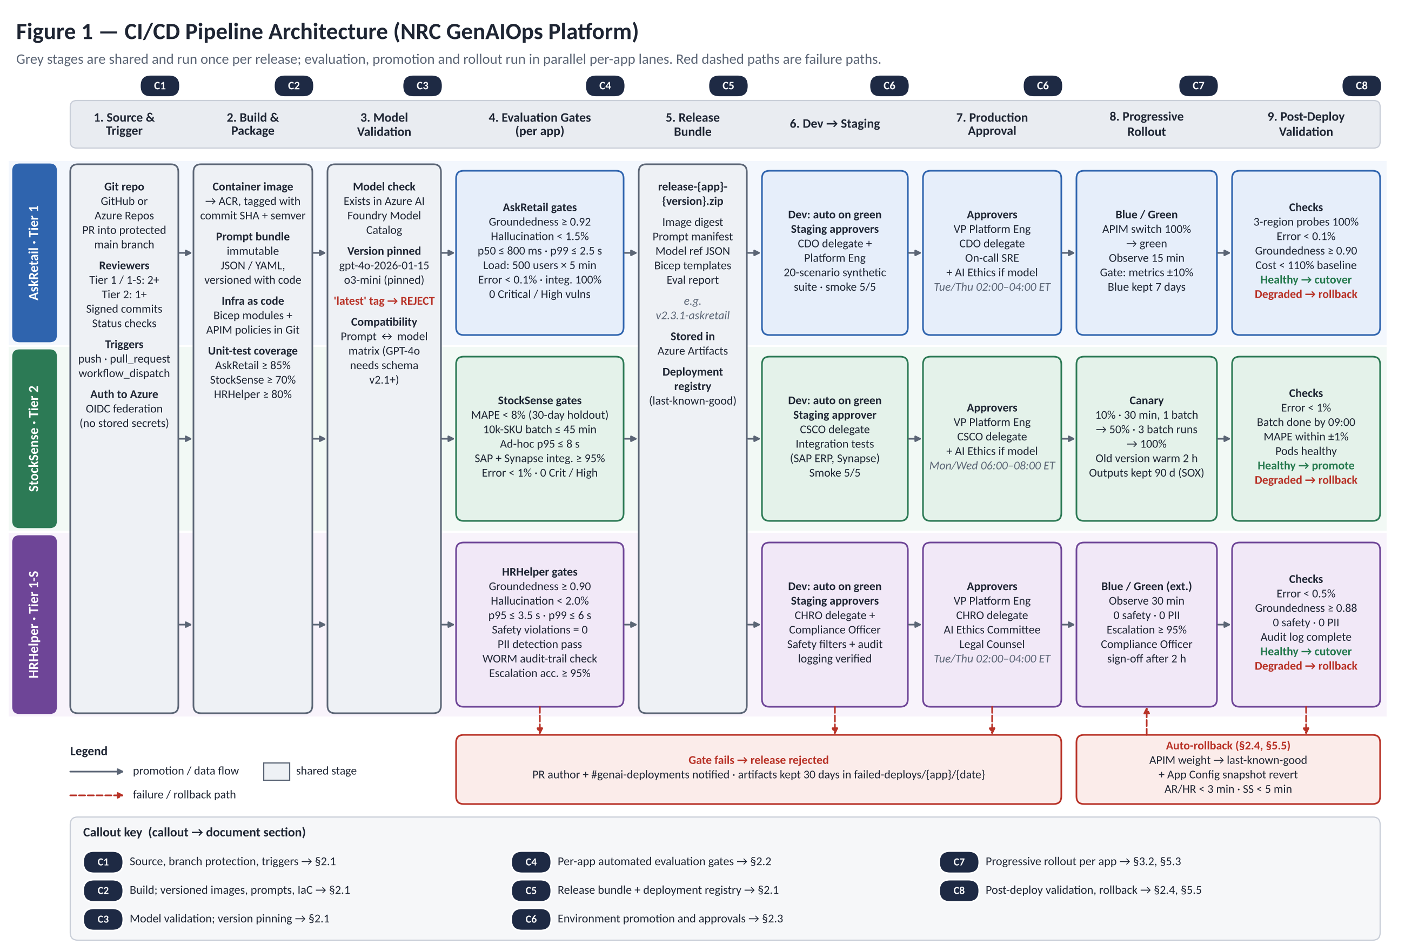
Figure 1. CI/CD pipeline: shared stages (grey) and parallel per-app lanes. Callouts C1–C8 map to §2, §3.2 and §5.

3. AI Gateway and Deployment Operations

3.1 Gateway responsibilities (C9–C12)
One Azure API Management Premium instance (East US primary, West US 2 secondary) is the AI gateway, exposing client app APIs and a model gateway that every LLM call crosses, so quotas and cost are measured once (Figure 2). AskRetail enters via Front Door with WAF; HRHelper uses an internal VNet gateway.
Responsibility | Design
Authentication (C9) | Entra ID token validation; per-app subscriptions; managed identity to Azure OpenAI, so apps hold no model keys.
Routing (C10) | Weighted pools per version run blue/green and canary; circuit breaker with cross-region failover; GPT-4o → GPT-4o-mini fallback when throttled.
Quotas and cost (C11) | Daily token budgets (AskRetail 4.5M, StockSense 1.2M, HRHelper 0.8M); token metrics tagged by CostCenter for showback; semantic cache for AskRetail.
API versioning (C12) | Path versions (/askretail/v2) for breaking changes, revisions otherwise; 60-day deprecation headers.
Safety | Content Safety and Prompt Shields; mandatory for HRHelper.

3.2 Progressive rollout per app (C7)
- AskRetail: blue/green. Zero downtime is the CDO’s priority, and one APIM weight change reverses a release in under 3 minutes, protecting the 15-minute MTTR target. After a 20-scenario synthetic suite, AskRetail’s volume surfaces regressions within 15 minutes, faster than a multi-hour canary. Only emergency fixes ship during BFCM.
- StockSense: canary 10% → 50% → 100%. Accuracy outranks speed and MAPE is only measurable on real batch output, so the canary must run production batches; 385 internal users tolerate a slow rollout. The Tier 2 window (Mon/Wed 06:00–08:00 ET) overlaps the morning batch, so the canary holds at 10% until the 09:00 deadline is met, limiting a bad build to one batch job.
- HRHelper: blue/green, 30-minute observation. A canary would split sensitive multi-turn conversations across versions and muddy the audit trail; blue/green keeps one auditable version per conversation behind zero-tolerance gates. A/B testing runs only offline, via evaluation replay.

3.3 Orchestrators and model/prompt versioning (C13–C14)
- AskRetail → AKS: zone-redundant pools in two regions with HPA and KEDA pre-scaling for BFCM; sub-second latency needs warm capacity.
- StockSense → Azure Container Apps: jobs run the batch and scale to zero after 09:00, revisions give weighted canaries, and time-series models stay on Azure ML endpoints, so NRC pays only for the batch window.
- HRHelper → dedicated private AKS in its own spoke VNet, so no shared node touches employee data.
Versioning is orchestrator-neutral: containers carry code only; every runtime reads model deployment, prompt version and feature flags from a per-release Azure App Configuration snapshot. Promotion and rollback change only the snapshot label and APIM weight, so releases behave identically on AKS and Container Apps, and a reverted snapshot reaches pods within 30 seconds.

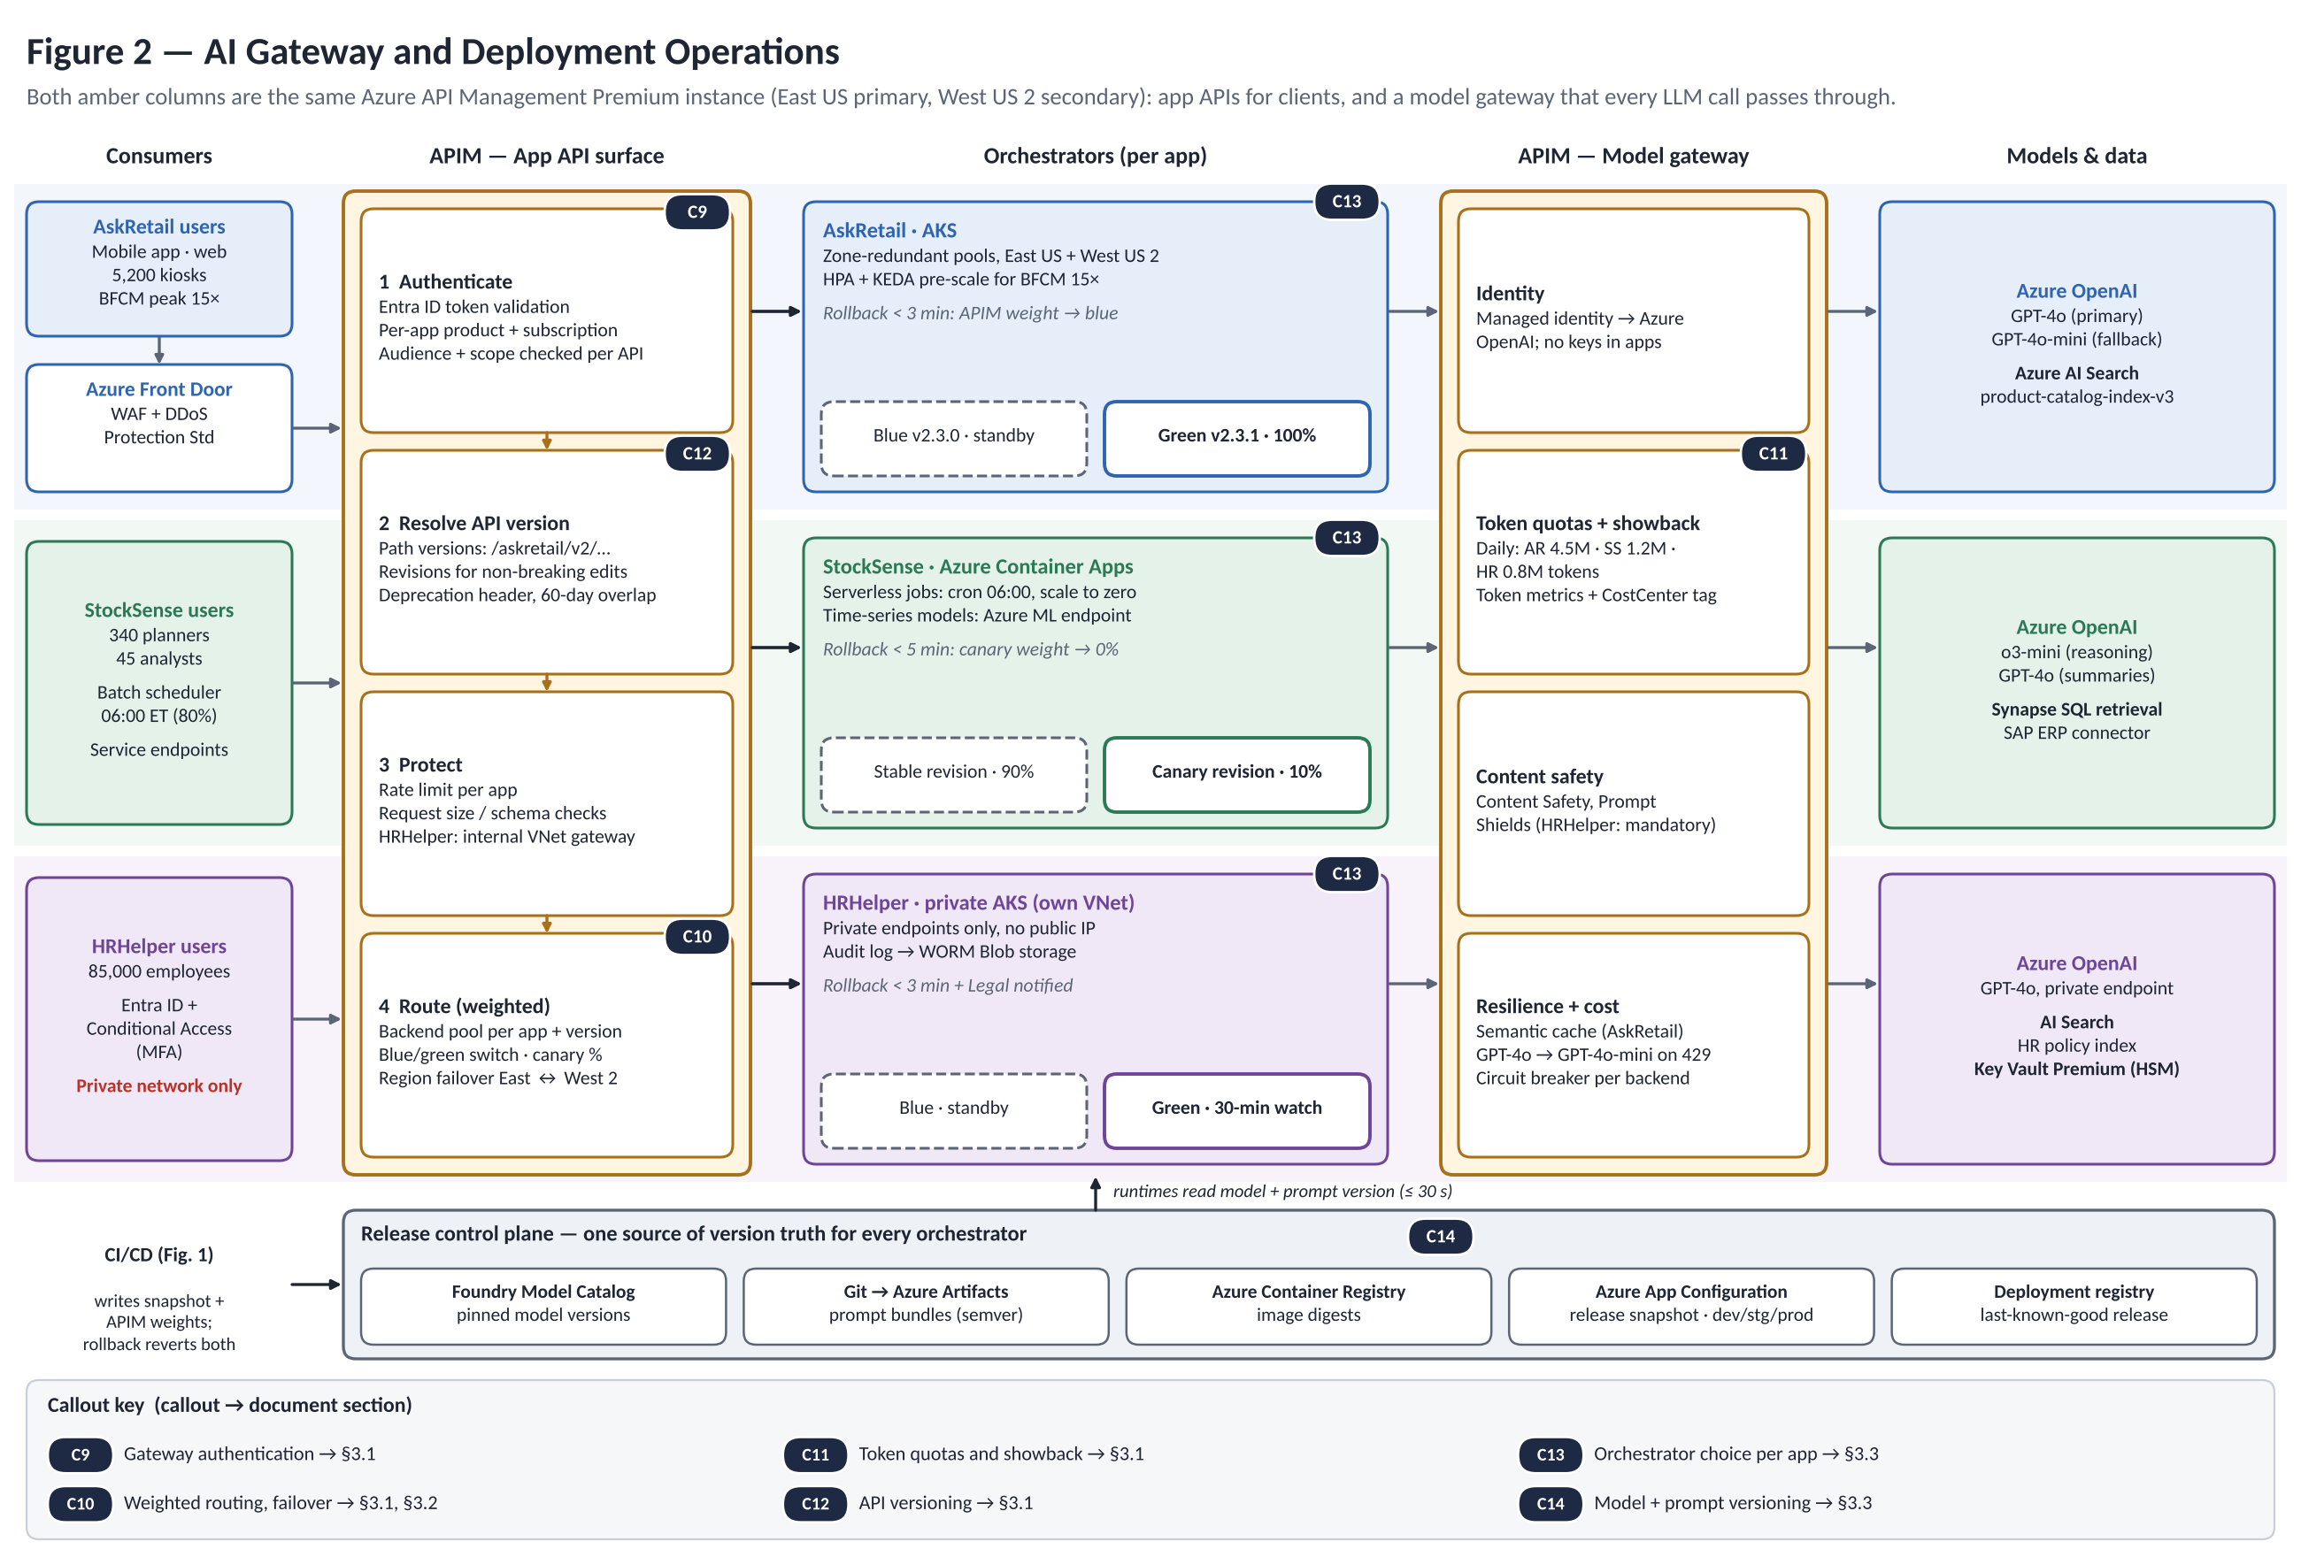
Figure 2. AI gateway surfaces, per-app orchestrators and release control plane. Callouts C9–C14 map to §3.

4. Observability Architecture

4.1 Tracing and telemetry capture points (C15)
W3C Trace Context propagates through six capture points (gateway, orchestrator, retrieval, inference, safety/quality, audit), exported via OpenTelemetry to Application Insights (Figure 3). Spans carry app version, pinned model, tokens, groundedness, hallucination flag, retrieval source and region, so regressions tie to a release, model or index. Sampling keeps all Tier 1 errors and 10% of successes.

4.2 LLM-specific metrics (C16)
Metric | Measurement | Threshold (AskRetail / HRHelper) → alert
Groundedness | AI Evaluation SDK (supported ÷ total claims) | ≥ 0.92 / ≥ 0.90; breached on > 5% of requests in 10 min → P2
Hallucination | Content Safety + self-consistency | < 1.5% / < 2.0%; > 3% in 30 min → P1, canary halt
Semantic drift | Embeddings vs. baseline (7 days) | KS > 0.15 or Wasserstein > 0.3 for 2 h → P2, replay
Tokens and cost | APIM token metrics | Quota > 75% → P3; cost > 150% of budget → P2
Safety and PII | Content Safety (0–6), Presidio | Severity ≥ 2 blocked; ≥ 4 → P1; PII leak → P0

4.3 Continuous evaluation (C17)
Event Hub samples live traffic (AskRetail 2%, every 4 h; StockSense 5% of batches; HRHelper 3%, every 6 h). An AKS job replays them against current and candidate model/prompt with the Azure AI Evaluation SDK; results land in Cosmos DB. Drift (two AskRetail metrics down > 5%, StockSense MAPE up > 1%, any HRHelper safety metric down) blocks promotion and alerts the owner, closing the loop to CI/CD.

4.4 Alert-to-severity mapping (C18)
Alert | Severity | Response | Routing
P0: outage, PII leak | SEV-0 | < 5 min | PagerDuty: SRE + VP Platform; CISO if security
P1: severe degradation, safety violation | SEV-1 | < 15 min | PagerDuty: SRE + App Owner
P2: quality or cost anomaly | SEV-2 | < 1 h | Teams + ticket
P3: minor breach | SEV-3 | < 4 h | Email + next-day ticket
P4: informational | None | None | Dashboard only

4.5 Dashboards (C19)
Platform Ops (Managed Grafana, 30 s refresh): health, latency, errors, tokens vs. quota, cost, alerts, releases. App Owner workbooks: groundedness and hallucination (AskRetail), MAPE and batch timeline (StockSense), escalation accuracy, safety and audit completeness (HRHelper). Executive/CFO Power BI: spend vs. the $1.4M target, cost per outcome, ROI, compliance.

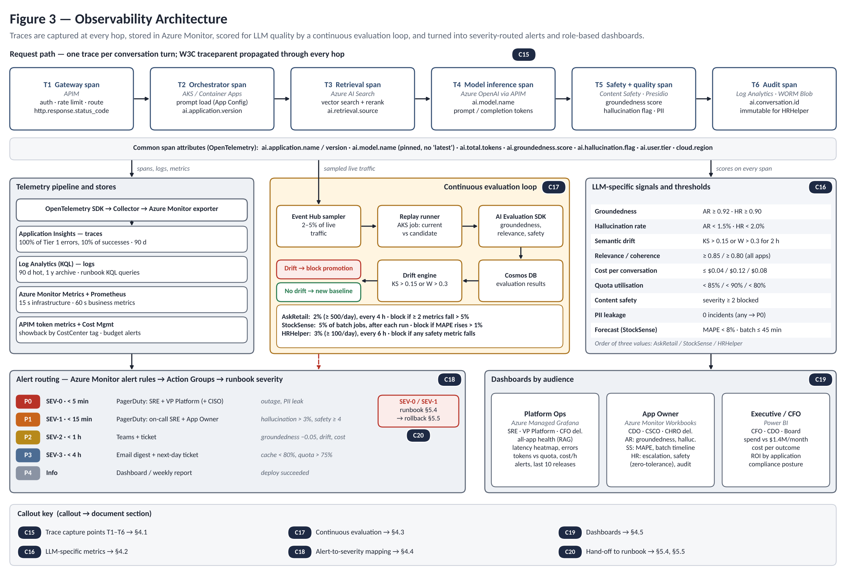
Figure 3. Trace capture, telemetry, continuous evaluation, alert routing and dashboards. Callouts C15–C20 map to §4 and §5.

5. Deployment Operations Runbook (C20)

5.1 Roles and escalation contacts
Role | Contact | Responsibility
On-call SRE | sre-oncall@nrc.internal; PagerDuty NRC-GenAI-SRE | Deploys, rollbacks, first response
Incident Commander | Senior SRE on rotation | Status updates, closure, post-mortem
VP Platform Engineering | platform-vp@nrc.internal | Escalation after 15 min (SEV-0/1)
CISO Security Operations | soc@nrc.internal | Security incidents only
App Owners | askretail-, stocksense-, hrhelper-owner@nrc.internal | Business impact, approvals
Compliance Officer, Legal | Via HRHelper owner | HRHelper standby, sign-off

5.2 Standard deployment
- Confirm the pinned release (semver, artifact SHA, no “latest”) and an all-PASS evaluation report.
- Check the window: Tier 1 Tue/Thu 02:00–04:00 ET; Tier 2 Mon/Wed 06:00–08:00 ET.
- Back up digest, prompt version, model reference and APIM config to production-backups/{app}/{date}.
- Announce in #genai-deployments; on-call acknowledges in PagerDuty (HRHelper: Compliance Officer on standby).
- Run the pipeline; staging smoke tests pass 5/5; record approvals.
- Validate: three-region probes 100%, tier error limit met, groundedness ≥ threshold − 0.02, cost < 110% of baseline, pods healthy, 0 Critical/High findings.
- Update the CMDB; close the ServiceNow change.

5.3 Progressive rollout
Follow §3.2 without skipping windows: AskRetail observes 15 min and keeps blue 7 days; StockSense steps 10% → 50% (three batch runs) → 100%, keeping the old version warm 2 h; HRHelper observes 30 min, then needs Compliance Officer sign-off after 2 h.

5.4 Incident detection and response (SEV-0/1)
- Detect: acknowledge within 5 min; open #incident-{timestamp}.
- Triage: classify (§4.4); notify App Owner, VP Platform, CISO (security), Legal (HRHelper).
- Contain: roll back (§5.5) or set the app’s APIM rate limit to 0; preserve evidence.
- Communicate: status.nrc.internal within 10 min, then every 30 min; executives within 15 min (SEV-0).
- Investigate via the decision tree: all apps → infrastructure; latency only → model or retrieval; quality only → model, prompt or index; security → CISO. No unapproved production changes.
- Resolve: re-run §5.2 step 6; monitor 1 h (SEV-1) or 4 h (SEV-0) before the all-clear.

5.5 Rollback execution
Shift APIM weight to the last-known-good release (blue/green 100%, canary 0%); revert the App Configuration snapshot; redeploy the old image only if the artifact is faulty; pass 5/5 smoke tests and watch 15 min; announce “Rollback to vX.Y.Z complete”; keep failed artifacts 30 days. Targets: under 3 min (AskRetail, HRHelper), under 5 min (StockSense).

5.6 Post-incident review
Confirm 24 h of baseline metrics, complete audit logs and recorded cost impact; lock evidence in WORM storage. Hold a blameless post-mortem within 24 h (SEV-0), 48 h (SEV-1) or 5 business days (SEV-2): timeline, 5-Whys root cause, impact, detection gaps and owned actions. Update this runbook after every SEV-0/1.
Sources: NRC Scenario Brief, CI/CD Pipeline Diagram Template, Observability Metric Examples and Deployment Operations Runbook (v2026.1); Azure Well-Architected Framework; NIST AI RMF 1.0.

